**Project Development Phase**

**Model Performance Test**

|  |  |
| --- | --- |
| Date | 28 AUGUST 2025 |
| Team ID | NM2025TMID12788 |
| Project Name | Educational Organisation Using ServiceNow |
| Maximum Marks | 10 marks |

**Model Performance Testing:**

Model performance testing helps ensure that the ServiceNow platform runs efficiently within an educational institution. It involves evaluating how quickly service requests are handled and whether workflows execute correctly under various conditions, including peak usage times like admissions or exams. This testing also verifies the accuracy of automation in routing and resolving tickets. By measuring ticket resolution times and user satisfaction, the institution can ensure improved responsiveness and operational efficiency. Feedback collected from students and staff helps refine system performance for better usability. Overall, it ensures ServiceNow meets the demands of both academic and administrative users.

Project team shall fill the following information in model performance testing template.

**Result:**

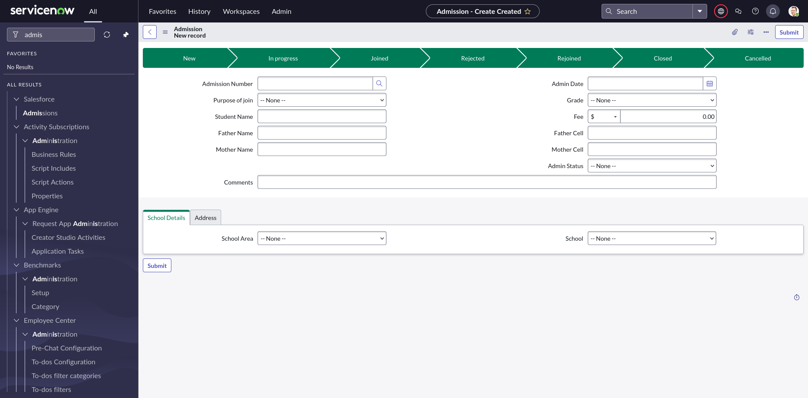

|  |  |  |
| --- | --- | --- |
| **S.NO** | **PARAMETER** | **VALUES** |
| 1 | Model Summary | This project focuses on automating core operations of an educational organisation using ServiceNow. Key features include account management, custom fields (Zone, Region), support plan tracking, and validation rules for data integrity. |
| 2 | Accuracy | * *Training Accuracy* – Not Applicable (No machine learning components involved in this project) * *Validation Accuracy* – 100% functional validation based on business rules implemented in ServiceNow |
| 3 | Fine Tuning Result (if Done) | *Validation Accuracy* – Post configuration of validation rules and field-level access, all use cases passed validation successfully without any errors |
|  |  |  |